

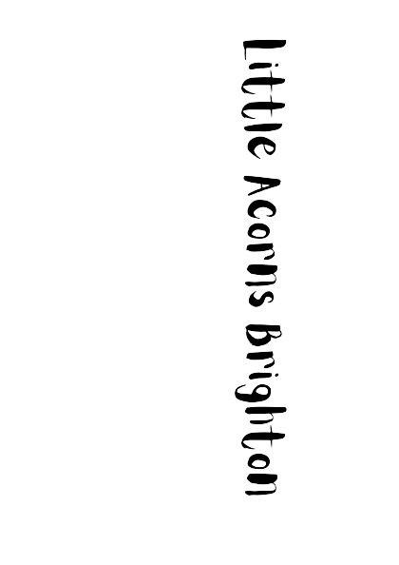

Fees

We understand how stressful organising childcare finances can be, so we offer a range of options for organising your childcare. If your needs are not met by any of the options below, then please email Bex at brightonlittleacorns@gmail.com and we will do our best to accommodate you.

All Children (9 months – 5 years)
Sessions per week | 1 | 2 | 3 | 4 | 5
Per full day | £78.00 | £78.00 | £78.00 | £78.00 | £78.00
Weekly | £78.00 | £156.00 | £234.00 | £312.00 | £390.00
Per half day | £42.00 | £42.00 | £42.00 | £42.00 | £42.00
Weekly | £42.00 | £84.00 | £126.00 | £168.00 | £210.00

Our low cost rates are all-inclusive and cover:
- Nappies
- Suncream
- Creams, lotions and wipes
- Morning snack & lunch (morning session)
- Afternoon snack & dinner (afternoon session)
- Early Years Foundation Stage teaching from Qualified Teachers
- Online access to our parent portal to access your child’s development profile and daily updates

We also accept Early Years Funding Entitlement (15 or 30 hours). Please see our EYFE funding pack to see how we spread our EYFE hours.

The Small Print

- Our fees are payable calendar monthly in advance by direct debit, tax-free childcare, bank transfer or nursery voucher on or before the 1st of each month.

- Our sessions are 8am-6pm for a full day; 8am-1pm for a morning session; and 1pm-6pm for an afternoon session.

- Your weekly fees will be converted to a calendar monthly amount so there is one regular payment coming out each month.

- If you are paying by voucher then please let us know the company you are using and ensure that your child’s name is used as the reference when the payment is made. If the voucher does not cover the entire fee, then any balance will be collected by direct debit. Please remember that both parents / carers are entitled to redeem the voucher.

- Tax-Free Childcare – our nursery can accept payments from this funding system scheme. More information can be found here:
https://childcare-support.tax.service.gov.uk/par/app/applynow

- In order to book a place at our Nursery, please contact us for a Registration Form and we will advise you of the fees and a holding fee of £100.

- On your first month’s payment, an additional deposit of one month’s fee will be payable. This deposit will be used to pay your final month with us, should you give the required notice period of one calendar month.

- There is a minimum booking commitment for all children of 4 half days or 2 full days. Bookings must be for the same session(s) each week and, as previously mentioned, appropriate notice must be provided for any changes.

- Extra sessions can either be paid for on the day or collected with the following month’s invoice. Extras are for additional sessions or additional hours and subject to availability.

