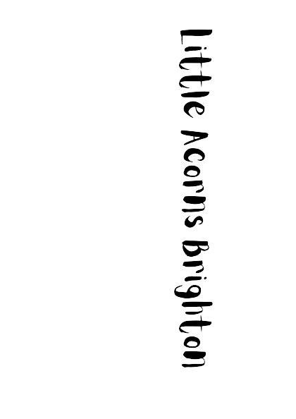

EYFE Funding

We understand how stressful organising childcare finances can be, so we accept EYFE funding across our full year. If would like to see what your tailor-made fee plan would look like, then please email Bex at brightonlittleacorns@gmail.com with the details of the sessions or hours you are wanting to take.
All three and four year olds and some children aged 9 months and over are, from the term after their birthdays, eligible for early years free entitlement (EYFE) funded hours 15 hours a week for 38 weeks per year (term-time only) or if the child attends year round, 570 hours stretched over the year. Some three and four year olds may be eligible for up to 30 funded hours a week (term-time only) 1140 stretched over the year. For further information go to the government’s childcare choices website .All eligible parents will receive an 11-digit code that they must share with their chosen childcare setting. The funding can be used at more than one setting.
‘Stretched’ 15 hour offer
Eligible children older than 9 months and all three and four year olds can have up to 15 hours per week for 38 weeks each year. As Little Acorns Nursery School is open 52 weeks per year we are able to stretch your entitlement over all these weeks.
EYFE only hours must include at least one full day on a Monday or Friday, unless we do not have availability on these days. In this circumstance we will offer a mid-week space. The remaining 50 hours will be offered as 5 ad hoc days (subject to availability) throughout the academic year.

EYFE does not cover the costs of meals, consumables, and additional extras, so there is a small additional fee to pay alongside your funded hours.
Your £7 per session covers the cost of:
• Nappies
• Suncream, creams, lotions and wipes
• Morning snack & lunch (morning session)
• Afternoon snack & dinner (afternoon session)
• Online access to our parent portal to access your child’s development profile and daily updates
• Outdoor puddlesuits for outside play whatever the weather
If you do not wish the nursery to provide these extras then we will advise you on what to bring in terms of meals, clothing and toiletries.
CHILDREN 9 months + (if eligible)
Full days per week | 1 | 2 | 3 | 4 | 5
EYFE Hours included | 10 hrs | 10 hrs | 10 hrs | 10 hrs | 10 hrs
Fees for teaching hours per day | £0.00 | £78 | £78 | £78 | £78
Fees for extras per day | £14 | £0 | £0 | £0 | £0
Weekly cost | £14 | £92 | £170 | £248 | £326
CHILDREN 9 months + (if eligible)
Half days per week | 1 | 2 | 3 | 4 | 5
EYFE Hours included | 5 hours | 10 hours | 10 hrs | 10 hrs | 10 hrs
Fees for teaching hours per day | £0.00 | £0.00 | £42 | £42 | £42
Fees for extras per day | £7 | £7 | £0 | £0 | £0
Weekly cost | £7 | £14 | £56 | £98 | £140
‘Stretched’ 30 hour offer
Currently, eligible three and four year olds may be entitled to up to 30 hours per week for 38 weeks each year. As Little Acorns Nursery School is open 52 weeks per year, we are able to stretch your entitlement over all these weeks.
EYFE only hours must include at least one full day on a Monday or Friday, unless we do not have availability on these days in which case a mid-week day may be offered. For those using the stand-alone stretched offer (20 hours per week) this will comprise 2 full days per week and an additional 10 ad hoc days (subject to availability) throughout the academic year.
EYFE does not cover the costs of meals, consumables, and additional extras, so there is a small additional fee to pay alongside your funded hours.
Your £5.60 per session covers the cost of:
• Nappies
• Suncream, creams, lotions and wipes
• Morning snack & lunch (morning session)
• Afternoon snack & dinner (afternoon session)
• Online access to our parent portal to access your child’s development profile and daily updates
• Outdoor puddlesuits for outside play whatever the weather
If you do not wish the nursery to provide these extras then we will advise you on what to bring in terms of meals, clothing and toiletries. 4
CHILDREN 3 YEARS+ (if eligible for 30hr funding)
Full days per week | 1 | 2 | 3 | 4 | 5
EYFE Hours included | 10 hrs | 20 hrs | 20 hrs | 20 hrs | 20 hrs
Fees for teaching hours per day | £0.00 | £0.00 | £78 | £78 | £78
Consumables fees for funded sessions per day | £14 | £14 | £0 | £0 | £0
Weekly cost | £14 | £28 | £106 | £184 | £262
CHILDREN 3 YEARS+ (if eligible for 30hr funding)
Half days per week | 1 | 2 | 3 | 4 | 5
EYFE Hours included | 5 hours | 10 hours | 15 hours | 20 hours | 20 hours
Fees for teaching hours per day | £0.00 | £0.00 | £0.00 | £0.00 | £42
Fees for extras per day | £7 | £7 | £7 | £7 | £0
Weekly cost | £7 | £14 | £21 | £28 | £70

​

The Small Print

- Our fees are payable calendar monthly in advance by direct debit, tax-free childcare, bank transfer or nursery voucher before the 1st of each month.

- Our sessions are 8am-6pm for a full day; 8am-1pm for a morning session; and 1pm-6pm for an afternoon session.

- Your weekly fees will be converted to a calendar monthly amount so there is one regular payment coming out each month.

- If you are paying by voucher then please let us know the company you are using and ensure that your child’s name is used as the reference when the payment is made. If the voucher does not cover the entire fee, then any balance will be collected by direct debit. Please remember that both parents / carers are entitled to redeem the voucher.

- Tax-Free Childcare – our nursery can accept payments from this funding system scheme. More information can be found here: https://childcare-support.tax.service.gov.uk/par/app/applynow

- In order to book a place at our Nursery please contact us for a Registration Form and we will advise you of the fees and a holding fee of £100.

- On your first month’s payment, an additional deposit of one month’s fee will be payable. This deposit will be used to pay your final month with us, should you give the required notice period of one calendar month.

- There is a minimum booking commitment for all children aged 0 to 5 years of 4 half days or 2 full days. Bookings must be for the same session(s) each week and as previously mentioned, appropriate notice must be provided for any changes. Bookings for free entitlement places where no additional hours are required are offered on an as available basis and we request that they include a Monday or Friday, although we will endeavour to accommodate your needs if we have availability.

- Extra sessions can either be paid for on the day or collected with the following month’s invoice. Credit cards are accepted for extras payments. Extras are for additional sessions or additional hours and subject to availability.

